Mentoring and Language Acquisition in Brazil 2013-2014
Midyear Report

Virtual Mentorship Program Dates: October 2013 – May 2014

January São Paulo Program Dates: January 20-24, 2014

Participants: 15 Harvard College students/15 Brazilian high school students

Organizing Institution: Harvard University, Brazil Office - David Rockefeller Center for Latin American Studies

Supporting Institutions: Colégio Ari de Sá; Colégio Bandeirantes; Colégio ETAPA; Primeira Chance

Program Partners: Fundação Estudar; ISMART; Fundação Lemann

The Mentoring and Language Acquisition in Brazil (MLAB) program aims to help reduce barriers for talented Brazilian youth with overwhelming potential and a strong desire to study in the world’s best universities. High-need, high-potential Brazilian students often lack sufficient English language skills and direct contact with role models who understand what it takes to make it to a place like Harvard. Harvard College mentors prepare and inspire Brazilian mentees to apply for college prep programs in Brazil and to top universities in the U.S through weekly one-on-one distance mentoring in English throughout the 2013-2014 year.

From January 20-24, 2014, DRCLAS led the Mentoring and Language Acquisition in Brazil (MLAB) program in São Paulo for the second time. Following a semester of distance mentoring via Skype, 15 Harvard College students met their 15 Brazilian high school mentees and engaged in a structured program of educational and cultural exchange. In addition to outings and time for one-on-one interaction, the 30 MLAB participants had the opportunity to discuss life goals, values, and personal trajectories with Jorge Paulo Lemann (Harvard College ’61), Flávia Almeida (Harvard Business School ’94; Harvard Board of Overseers), Claudio Sassaki (Founder of Geekie, an education start-up), and representatives from Fundação Estudar. Local partner organizations that have made the program possible (Colégio Bandeirantes, Colégio Etapa, Colégio Ari de Sá, Primeira Chance, Fundação Estudar, Fundação Lemann, and ISMART) actively engaged in and supported the program throughout the week. MLAB continues through the end of 2013-2014 with distance mentoring and virtual group meetings.

MLAB OVERALL
Number of Respondents = 30

Overall rating of the MLAB program | % Rated 4 or 5 (0=worst, 5 = best)
 | 100%
Would you recommend this program to other students? | % Responded “Definitely Would”
 | 100%
Please provide an overall rating for the virtual mentorship program. | % Rated 4 or 5 (0=worst, 5 = best)
 | 90.3%
Please provide an overall rating for the January program. | % Rated 4 or 5 (0=worst, 5 = best)
 | 100%
Has the program improved your English/Portuguese language skills? | % Responded “Yes”
 | 100%
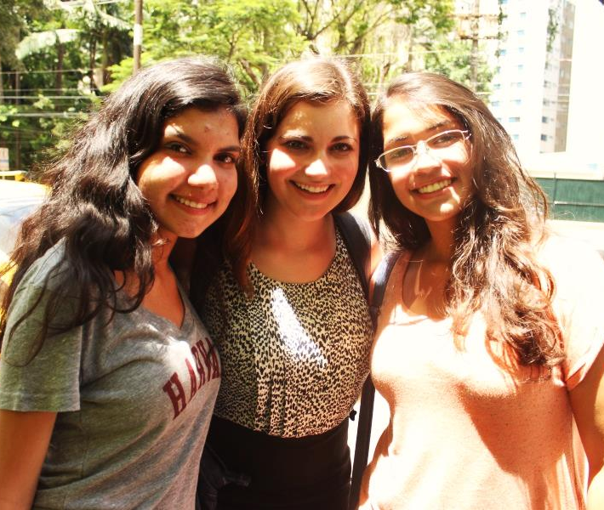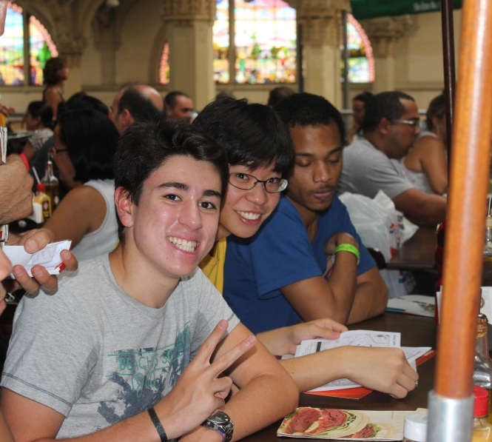
Guilherme Quadros Calazans (Bandeirantes, ISMART), Kevin Iwashita (ETAPA), and Andrew Vincent (Harvard) enjoy lunch at the Mercado Municipal.
Joany D’avila de Oliveira Silva (Bandeirantes, ISMART), Amanda Rodrigues (Harvard), and Camila Marques de Oliveira (ETAPA) pose for a quick photo in São Paulo.

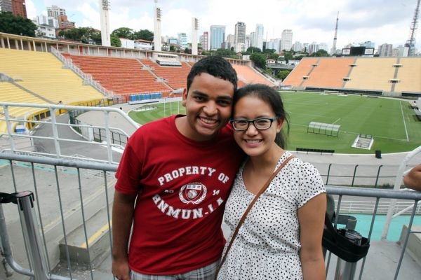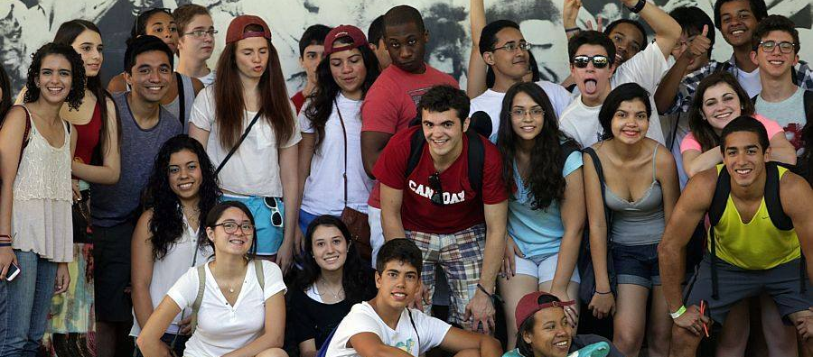
MLAB mentees and mentors have fun taking photos for the Estadão photographer outside the Museu Afro-Brasil.
Rodrigo Silva Ferreira (Ari de Sá, Primeira Chance) and his mentor Rainjade Chung (Harvard) enjoy their time at the Museu do Futebol.

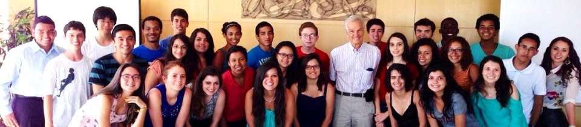
MLAB participants pose after an animated conversation with Jorge Paulo Lemann.

